
UNIVERSITI MALAYSIA TERENGGANU

MDA3083 - PREDICTIVE ANALYTICS

TITLE:
DATA REDUCTION AND BIG DATA USING PCA ON SUPERSTORE DATASET

PREPARED FOR:
DR. SHARIFAH SAKINAH BINTI SYED ABD MUTALIB

PREPARED BY:
GROUP 7
NO. | MATRIC NO. | NAME
1 | S76066 | TAN JIA TAI
2 | S76110 | AISYAH BINTI ABDUL HALIM
3 | S76111 | ALYA SYAKIRAH BINTI ZAKARIA
4 | S76121 | ATHIRAH YUMNI BINTI AHMAD BAHRI
5 | S76122 | AULA BINTI NOR EFENDI

1.0 Introduction
In the era of big data, businesses generate large amounts of information from daily operations. Managing and analyzing complex data can be challenging because of the redundancy among variables. For this reason, data reduction techniques are important. They help simplify datasets while keeping essential information.
This study uses Principal Component Analysis (PCA), a common data reduction technique, on the Superstore Dataset. PCA converts related variables into fewer uncorrelated principal components while maintaining most of the original information. The goal of this study is to reduce data dimensionality and identify the main factors that influence sales performance in a retail environment.

2.0 Data Description
Table 2.0: Dataset Information
Item | Description
Dataset Name | Superstore Dataset
Source | Kaggle Superstore Sales Dataset
Industry | Retail Business
Number of Observations | 9,994
Number of Variables | 21
Software Used | R 4.6.0

3.0 Methodology
3.1 Dataset and Data Source
In this study, a Superstore Dataset that can be downloaded from a public data repository called Kaggle was used (Kaggle, 2023). The Superstore Dataset, which has 9,994 instances and 21 variables, is widely used for data analysis and for a study using machine learning techniques. The data contain retail business transaction information and variables of sales performance and customer information as well as product information, places of geographical locations, discount, and profit, etc.
The Superstore dataset is selected because it contains many variables that can be used for multivariate analysis, and for reducing dimensionality. The dataset was obtained from an existing data source; therefore, no primary data collection was required for this study. The data set is obtained from an existing data source, thus there is no need for primary data collection for this study.
For the Principal Component Analysis (PCA), only the numerical variables of this Superstore dataset have been used. The following four variables have been chosen because they are the main indicators that measure a retailer’s performance. The variables are Sales, Quantity, Discount, and Profit.

3.2 Data Exploration
An exploratory study was carried out to comprehend the structure and properties of the dataset before PCA. This phase is crucial as it ensures that the data are suitable for further analysis and provides an overview of the variables included in the study. Prior to conducting the PCA analysis, a data quality assessment was performed to evaluate the reliability of the dataset. Missing value detection and duplicate record checking were conducted, and the results indicated that the Superstore dataset contained no missing values and no duplicate observations. Therefore, no data cleaning procedures, such as record removal or imputation, were required, and the dataset was considered ready for analysis.
After importing the dataset into R, summary statistics and data inspection techniques were used to explore the data. The exploration process involved examining the distribution of the selected numerical variables, identifying variable types, and verifying the number of observations in the dataset. Descriptive statistics, including minimum values, maximum values, means, and medians, were examined to better understand the characteristics of the selected variables.
The variables selected for the PCA analysis represent different aspects of retail business performance. Sales refers to the revenue generated from transactions, Quantity represents the number of products purchased, Discount indicates the price reductions offered to customers, and Profit measures the earnings generated from each sale. Together, these variables provide a comprehensive representation of retail operational performance and form the basis for the subsequent PCA analysis.

3.3 Principal Component Analysis (PCA)
Principal Component Analysis or PCA is a method that helps simplify a dataset by reducing its dimensions. It keeps as much information as possible from the original variables. PCA changes a set of variables into a smaller set of unrelated variables called principal components.
In this study we used PCA with the princomp() function in R Studio. We used the correlation matrix for the analysis by setting cor = TRUE.
The PCA procedure involved the following steps:
- Importing the Superstore Dataset into R.
- Select the variables to analyze.
- Performing PCA using the princomp() function.
- Obtained the eigenvalues of the components.
- Calculate how much of the variance is explained by the components.
- Examining the component loadings.
- Generating a Scree Plot.
- Producing a PCA Score Plot.
The principal components obtained from the analysis provided a simplified representation of the original variables while retaining most of the information contained in the dataset.

3.4 Eigenvalue Analysis
Eigenvalues were obtained from the PCA output to determine the amount of variation explained by each principal component. Components with larger eigenvalues explain a greater proportion of the total variation in the dataset and are therefore considered more important. The eigenvalues were calculated using the following command:
eiv <- sp.pca$sdev^2
The cumulative proportion of variance explained by the principal components was calculated using:
cumsum(eiv)/sum(eiv)
The cumulative variance was used to evaluate how much information could be retained after dimensionality reduction. This measure assists in determining the effectiveness of PCA in summarizing the original dataset.

3.5 Components Loadings
Component loadings were examined to determine the contribution of each original variable to the principal components. The loadings were extracted from the PCA output using:
loadings <- sp.pca$loadings
The loading values indicate the strength of the relationship between the original variables and the principal components. Variables with larger loading values contribute more strongly to a component and are useful for understanding the characteristics represented by each principal component. The component loadings were subsequently used in the interpretation of the PCA results.

3.6 Data Visualization
Graphical techniques were used to support the PCA analysis and provide a visual representation of the results.

- Scree Plot
A Scree Plot was generated to display the eigenvalues of the principal components. The plot illustrates the amount of variation explained by each component and provides a visual summary of the PCA results.

- PCA Score Plot
A PCA Score Plot was generated using the component scores obtained from the PCA output. The score plot displays the observations according to the first two principal components and provides a graphical representation of the overall distribution of the dataset.
However, because the Superstore Dataset contains a large number of observations (9,994 records), the individual data points are highly concentrated and overlap considerably. As a result, it is difficult to identify specific patterns or relationships through visual inspection alone. Therefore, the PCA Score Plot was included primarily as a supporting visualization rather than as a tool for detailed interpretation.
Detailed interpretations of the principal components were instead based on the eigenvalues, cumulative variance, and component loadings obtained from the PCA output.

4.0 Results and Discussion
4.1 Principal Component Analysis Results
Principal Component Analysis (PCA) was performed on four numerical variables from the Superstore Dataset, namely Sales, Quantity, Discount, and Profit. The analysis was carried out using the correlation matrix with the princomp() function in R Studio.
The PCA output produced four principal components. The summary of the eigenvalues and proportion of variance explained by each component is shown in Table 4.1.
Table 4.1: Eigenvalues and Variance Explained
Principal Component | Eigenvalue | Proportion of Variance (%) | Cumulative Variance (%)
PC1 | 1.590 | 39.75 | 39.75
PC2 | 1.059 | 26.47 | 66.22
PC3 | 0.881 | 22.03 | 88.25
PC4 | 0.470 | 11.75 | 100.00

From Table 4.1, the first principal component (PC1) explained 39.75% of the total variation in the dataset. The second principal component (PC2) explained an additional 26.47% of the variation. Together, PC1 and PC2 accounted for 66.22% of the total variance.
The cumulative variance increased to 88.25% when the first three principal components were considered. However, the contribution of PC4 was relatively small, explaining only 11.75% of the total variation.
These results indicate that most of the information contained in the original variables can be represented using fewer dimensions.

4.2 Selection of Principal Components
The eigenvalues obtained from the PCA were used to determine the number of components to retain.
According to the Kaiser Criterion, only principal components with eigenvalues greater than one should be retained. Based on Table 4.1, only PC1 and PC2 satisfy this criterion, with eigenvalues of 1.590 and 1.059 respectively.
Therefore, two principal components were retained for further interpretation. By reducing four original variables to two principal components, dimensionality reduction was successfully achieved while preserving approximately 66.22% of the total information contained in the dataset.

4.3 Scree Plot and Score Plot Analysis
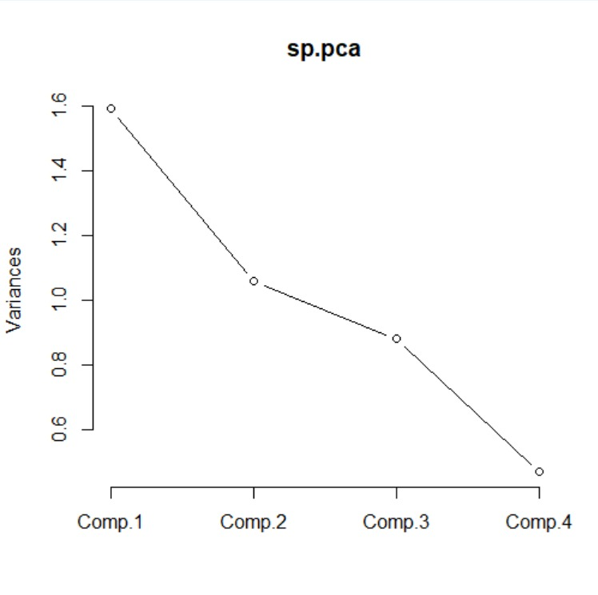
Figure 4.3.1 Scree Plot
The scree plot shows that the eigenvalues decrease gradually from PC1 to PC4. The first two components have eigenvalues greater than 1:
- PC1 = 1.590
- PC2 = 1.059
According to the Kaiser Criterion, components with eigenvalues greater than 1 should be retained. Therefore, PC1 and PC2 are retained, while PC3 and PC4 may be excluded from further analysis.
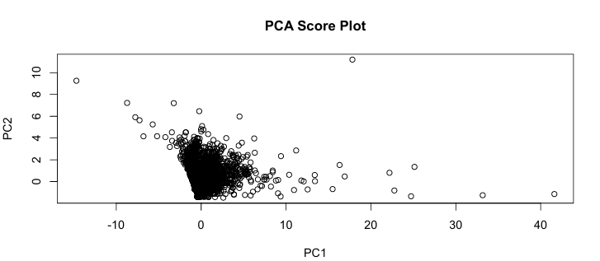
Figure 4.3.2 Score Plot
Figure 4.2 presents the PCA Score Plot based on the first two principal components. Due to the large number of observations in the dataset, many points overlap, making it difficult to distinguish individual observations and identify clear patterns visually.
Therefore, the score plot serves mainly as a graphical representation of the distribution of observations, while the interpretation of the PCA results is primarily based on the eigenvalues, cumulative variance, and component loadings discussed in the previous sections.

4.4 Principal Component Loadings
Table 4.4: PCA Loadings
Variable | PC1 | PC2
Sales | 0.643 | 0.218
Quantity | 0.289 | 0.631
Discount | -0.270 | 0.719
Profit | 0.655 | -0.195

PC1 has strong positive loadings for Profit (0.655) and Sales (0.643). This indicates that PC1 mainly represents business performance and revenue generation. Transactions with high sales values tend to generate higher profits. Therefore, PC1 can be labeled as: Business Performance Component.
PC2 has strong positive loadings for Discount (0.719) and Quantity (0.631). This indicates that PC2 reflects sales promotion and purchasing behavior. Customers tend to purchase larger quantities when discounts are offered. Therefore, PC2 can be labeled as: Discount and Purchasing Behavior Component.

4.5 Correlation Analysis
The correlation between Sales and PC1 is:
r = 0.81
while the correlation between Sales and PC2 is:
r= 0.22
The strong positive correlation between Sales and PC1 indicates that sales performance is the major factor driving variation within the dataset. In contrast, PC2 has a relatively weak relationship with Sales, suggesting that it captures different information related to discount strategies and quantity purchased.

4.6 Business Implication
The PCA result provides several important business insights:
- Sales and Profit are closely related and contribute significantly to overall business performance.
- Discount and Quantity form another important dimension of customer purchasing behavior.
- The dataset can be reduced from four variables to two principal components while retaining approximately 66% of the original information.
- Managers can focus on these two components to simplify business analysis and decision making.

5.0 Conclusion
Based on the PCA result, two principal components were retained. These two components explain 66.22% of the total variance and successfully summarize the information contained in the original variables.PC1 represents business performance through sales and profit, while PC2 represents discount strategy and purchasing behavior. Therefore, PCA effectively reduced the dimensionality of the Superstore dataset and simplified the analysis of retail business performance.

6.0 References
- Superstore Dataset: Dataset containing Sales & Profits of a Superstore
https://www.kaggle.com/datasets/vivek468/superstore-dataset-final
- R Documentation princomp: Principal Components Analysis
https://www.rdocumentation.org/packages/stats/versions/3.6.2/topics/princomp
- Jolliffe, I. T. (2016). Principal Component Analysis (2nd ed.). Springer.
- ur Rehman, M. H., Liew, C. S., Abbas, A., Jayaraman, P. P., Wah, T. Y., & Khan, S. U. (2016). Big data reduction methods: a survey. Data Science and Engineering, 1(4), 265-284.
- Badakhshan Farahabadi, F., Fathi Vajargah, K., & Farnoosh, R. (2021). Dimension reduction big data using recognition of data features based on copula function and principal component analysis. Advances in Mathematical Physics, 2021(1), 9967368.
- Rani, R., Khurana, M., Kumar, A., & Kumar, N. (2022). Big data dimensionality reduction techniques in IoT: Review, applications and open research challenges. Cluster Computing, 25(6), 4027-4049.
- Principal Component Analysis in R Programming | How to Apply PCA | Step-by-Step Tutorial & Example
https://youtu.be/mNpBrHwOCt4?si=ZH7G1zi0gdOeLWTq

